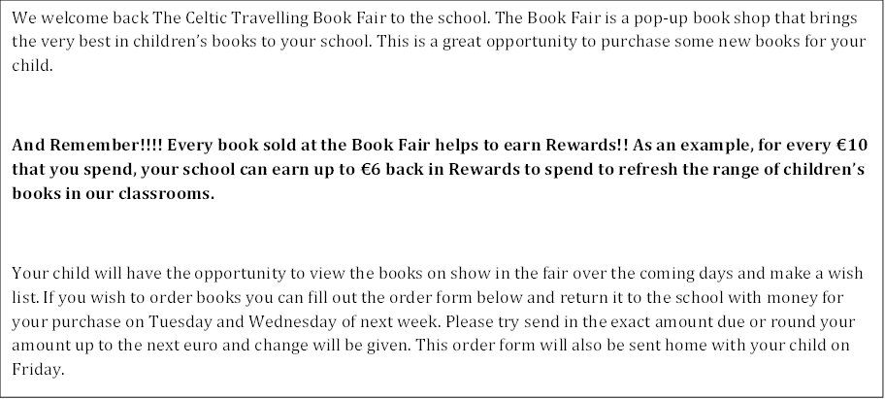

Please choose your titles **from the attached catalogue** and complete the Order Form with your payment details. Please return your order to the school who will supply the books from the Book Fair. Don’t forget you can avail of the 3 for 2 offer!!

|  |  |  |  |  |
| --- | --- | --- | --- | --- |
| **Title** | **Price** | **Quantity** | | **Total** |
|  |  |  | |  |
|  |  |  | |  |
|  |  |  | |  |
|  |  |  | |  |
|  |  |  | |  |
|  |  |  | |  |
|  |  |  | |  |
|  |  |  | |  |
|  | **Total Order Value** | |  | |
| Child’s name: | Class: | | | |
| Parent’s name: | | | | |